Please select the link below to download for Original Files to follow the course and participate with the activities.

When you click the file, you may be prompted to a page that looks like the one below. Simply select download.

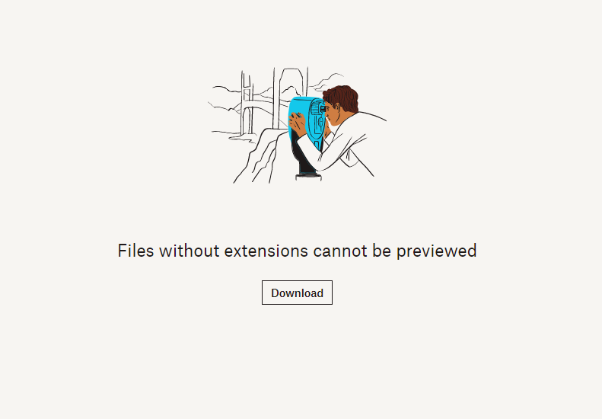

File name: VW DSG ORI

https://www.dropbox.com/s/mujxf3wgplya8u0/VW%20DSG%20ORI?dl=0

Please enjoy your course.

Kind regards
Team Remap101.co.uk

e :info@viezu.com
t: +44 (0) 1789 774444

